Hi, Subcontractor Name,

As part of a new initiative to improve our Subcontractor PQQ, tendering, and subcontract process, we’ll introduce the [C-Link/Prosper Portal](https://c-link.com/), a subcontract procurement management software.

The adoption and use of the C-Link/Prosper Portal at your company name will allow:

* One-time Completion and update of all your PQQ Requirements
* Quick submission and response to tender queries and quotations
* Issuance and signing of subcontract Orders.

As a valued member of our supply chain, you will be invited to register with C-Link/Prosper; registering and using the C-Link/Prosper Portal will be free.

From a subcontractor standpoint, once you have activated your Prosper account and created your password, Go to My Company > Prequalification area of your account and complete your PQQ Information.

**Next Steps**

You will receive an introduction email from The Prosper Team on the (XX/XX/202X) inviting you to activate your account (check Spam or Junk folders). Please watch out for and action this email.

*See the introduction email example below.*



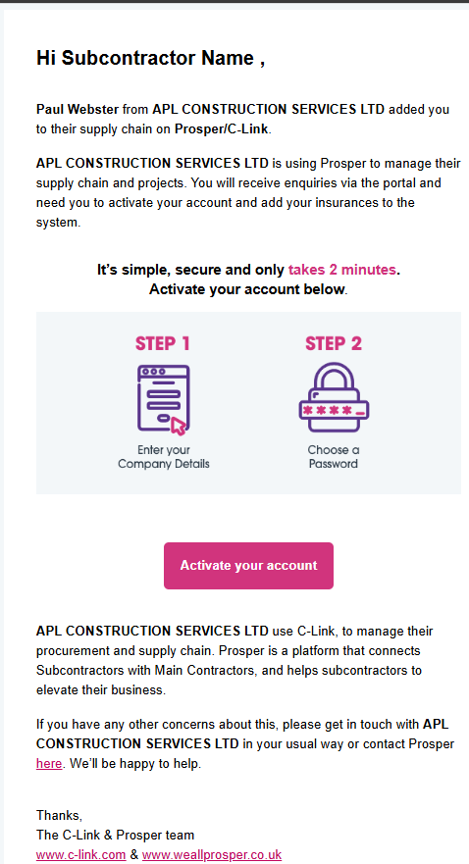

Please contact me if you have any queries concerning the above.

Kind regards,

Your Company Name